**Euphrates: Algorithm-SoC Co-Design for Low-Power Mobile Continuous Vision**

**Authors**

1. **Yuhao Zhu** University of Rochester
2. **Anand Samajdar** Georgia Institute of Technology
3. **Matthew Mattina** ARM Research
4. **Paul Whatmough** ARM Research

**Keywords:**

1. Convolutional neural networks (CNN)
2. Inference acceleration
3. Low power, high energy efficiency, high performance
4. Continuous vision application (Object Tracking, Object Detection)
5. Motion information between consecutive frames
6. Mobile SoC architecture design
7. Algorithm-architecture co-design
8. Software-hardware co-design

**Summary**

*Challenge*

Today’s continuous vision algorithms treat each frame as a standalone entity and thus execute an entire CNN inference on every frame, which is compute-inefficient and energy-inefficient in continuous vision application (extracting high-level semantic information from real-time video streams such as object detection and object tracking) and impractical on mobile computing architecture because of limited compute capability under limited mobile power budget.

Besides, A typical continuous computer vision pipeline consists of two parts: a frontend and a backend, in which the frontend prepares pixel data for the backend and the backend in turn extracts semantic information for high-level decision making. However, most solutions treat these two parts as totally independent steps, that means, the frontend and the backend are realized through different IPs even through different chips designed by different manufactures, causing that they share nothing but pure pixel data without further synergy. This design method will introduce heavy bus data transmission and frequent CPU interrupting, which is unsuitable for mobile computing architecture.

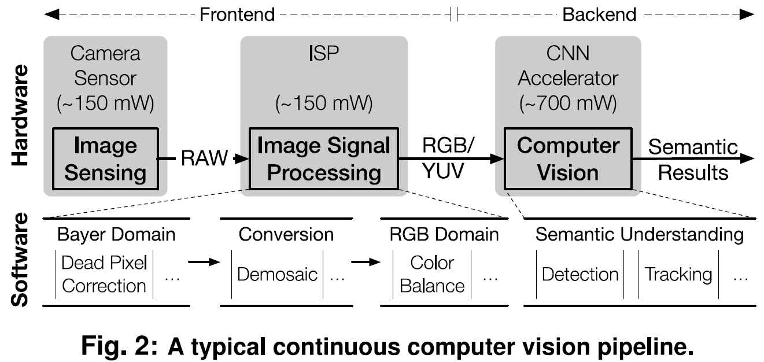

*Contributions*

This paper develops Euphrates, a proof-of-concept system of algorithm-SoC co-designed approach. The main contributions of this paper are as follows:

1. This paper proposes a new algorithm that leverages the temporal pixel motion to synthesize vision results on many frames with little computation while avoiding expensive CNN inferences, which improve compute efficiency of continuous vision with small accuracy loss.
2. This paper designs the mobile SoC architecture to support new algorithm with two highlights. First, this paper greatly improves the compute efficiency by exploiting sharing motion data across the ISP and other IPS in a mobile SoC. Second, this paper proposes the *motion controller*, a new IP that autonomously coordinates the vision pipeline during CV tasks avoiding frequent CPU interrupting to save computing energy.
3. This paper models a commercial mobile SoC, validated with hardware measurements and RTL implementations, and demonstrate significant energy savings with little accuracy loss.

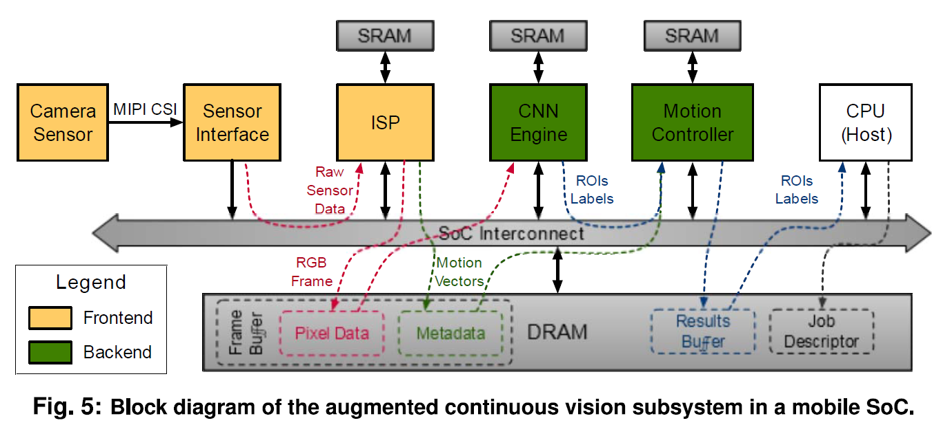

*Experiments and Results*

This paper develops an in-house simulator with a methodology similar to the GemDroid SoC simulator. The simulator includes a functional model, a performance model, and a power model for evaluating the continuous vision pipeline. The functional mode will derive accuracy results. The performance model captures the timing behaviors of various vision pipeline components and the models the timing of across-IP activities, from which this paper then tabulate SoC events that are fed into the power model for energy estimation. This paper uses Tiny YOLO and YOLOv2 for object detection experiment and MDNet for Object Tracking. The results show that Euphrates achieves up to 66% SoC-level energy savings (4x for the vision computations) with only 1% accuracy loss.

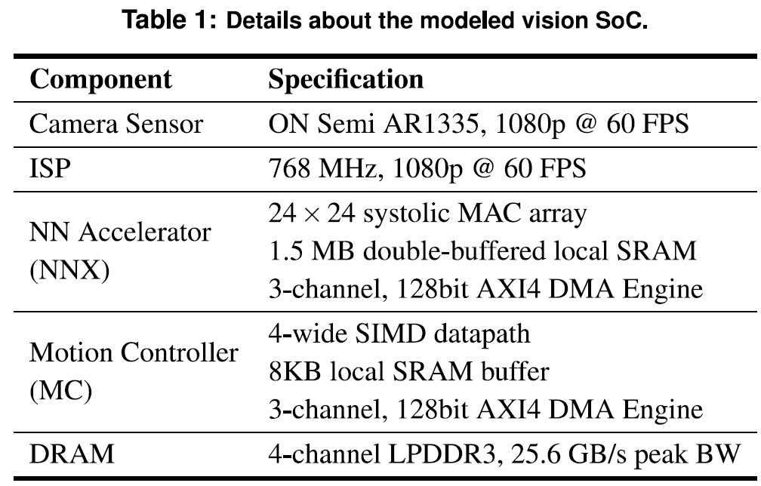

*Comments*

The goal of this paper is to improve the compute efficiency of continuous vision with small accuracy loss, thereby enabling new mobile use cases. The key contributions of this paper are not the proposed algorithm that uses emotion information because there are already some similar algorithms proposed before. This paper doesn’t focus on the detail architecture of any IP but delivers readers an algorithm-architecture and hardware-software co-design approach to save overall computing energy from a SoC-level perspective, which values most. Besides, the simulator developed by this paper is very convincing and is worth learning for our research. The only disadvantage of this paper is that it does not detail the dataflow control and software design aspects.